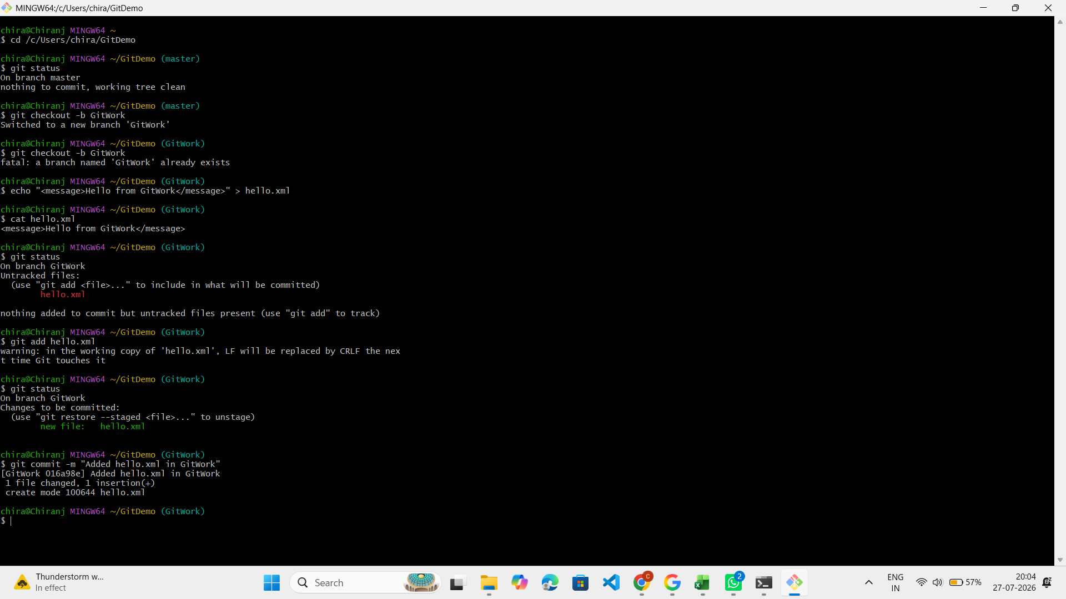
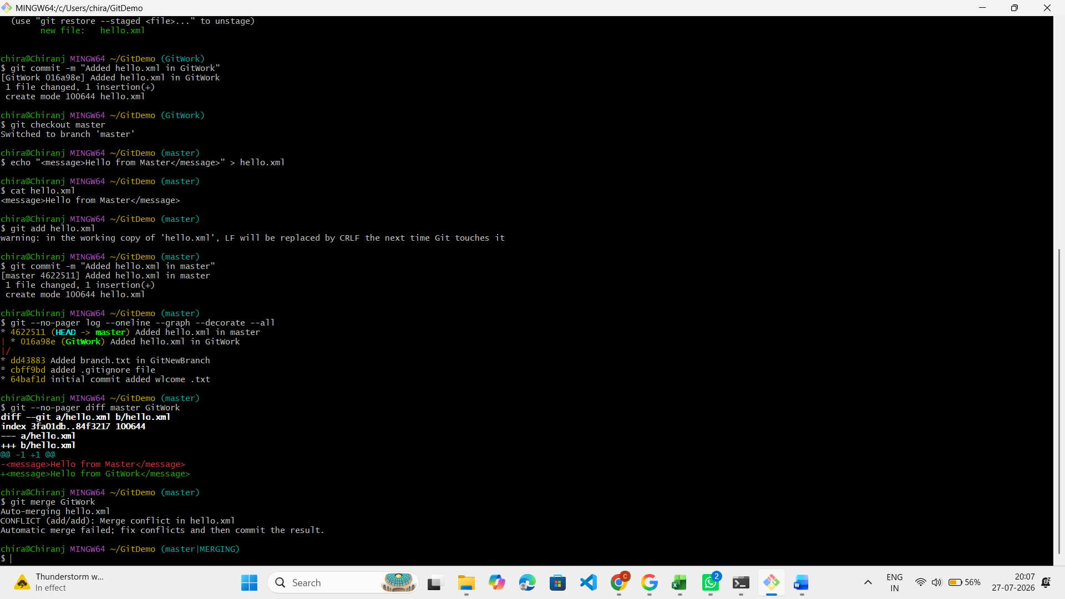
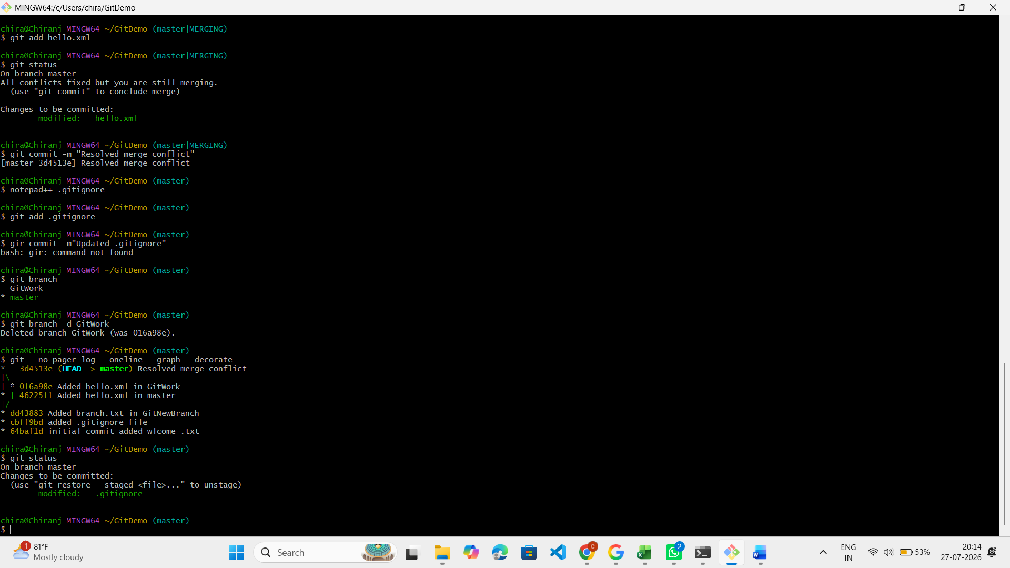
# Go to the repository
cd /c/Users/chira/GitDemo

# Verify master is clean
git status

# Create and switch to a new branch
git checkout -b GitWork

# Create hello.xml in GitWork
echo "<message>Hello from GitWork</message>" > hello.xml

# Verify file
cat hello.xml

# Check status
git status

# Add file
git add hello.xml

# Verify staged file
git status

# Commit changes
git commit -m "Added hello.xml in GitWork"

# Switch to master
git checkout master

# Create hello.xml with different content
echo "<message>Hello from Master</message>" > hello.xml

# Verify file
cat hello.xml

# Add file
git add hello.xml

# Commit changes
git commit -m "Added hello.xml in master"

# View commit history
git --no-pager log --oneline --graph --decorate --all

# Compare master and GitWork
git --no-pager diff master GitWork

# Merge GitWork into master (this creates the conflict)
git merge GitWork

# Open the conflicted file
notepad++ hello.xml

# In Notepad++, replace the conflict markers with:
# <message>Hello from Master and GitWork</message>

# Stage the resolved file
git add hello.xml

# Verify merge status
git status

# Complete the merge
git commit -m "Resolved merge conflict"

# Open .gitignore
notepad++ .gitignore

# Add this line:
# *.bak

# Save and close, then commit
git add .gitignore
git commit -m "Updated .gitignore"

# List all branches
git branch

# Delete merged branch
git branch -d GitWork

# View final commit history
git --no-pager log --oneline --graph --decorate

# Final status
git status

